FOR IMMEDIATE RELEASE: 2nd August 2016
WHAT started out as a project inspired by a simple line drawing has concluded with Bristol based Artist, Elaine Robinson, landing a permanent spot in one of the country’s most prestigious libraries, and dates set for a second UK tour with her upcoming roaming collective artwork,SPOTtimespotTIME.
Professional Artist, Elaine Robinson, previously a business entrepreneur, decided that the time had finally come to embrace and pursue her first love, taking the plunge into a career as a full-time Artist in 2007.
And now one of her major projects to date, Turning ‘ages, has been chosen as an installation, permanently on display to the public at Westminster Reference Library.
The 50-year-old worked on the Turning ‘ages project for several years; the first in a series of artworks, designed to cast a critical eye on various aspects of modern life.
The project started when Robinson came across a drawing of a road in Paris in a 19th Century map book which she found back in the 1990s. But it was nearly two decades later that she was finally able to make use of inspiration that had lain dormant for so long, and this was the catalyst for creating Turning ‘ages and her subsequent community projects.
Elaine, who lives in Bristol, said: “I have always been interested in books and the impact they can have on people’s lives.”
“I wanted to look at the role that libraries play in what is a rapidly changing world. There have been major debates raging about the future of libraries andTurning ‘ages was an attempt to examine that debate by reminding people what a crucial part libraries and books have played in their lives and documenting peoples personal opinions and memories.”

“Turning ages explores our communication with the written word and promotes our relationship with books and libraries in the face of advancing technologies. The large Glass Cabinet showcases a collection of objects, highlighting the intimate and complex relationship between people, books and the everyday ephemera that is left forgotten or misplaced between their pages. Turning ‘ages exists as a permanent reminder of peoples stories, past and present, an archive that acts as a catalyst for comment during the ever changing and transitional relationship between the physical book and the written word.”
The work has toured UK libraries giving participants the chance to make their own unique contribution to the work with their personal stories and ideas. The library project has also won the backing of the South West Arts Council.
Phil Gibby, from the organisation, said: “We are really pleased to be supporting the tour of this thoughtful exhibition that explores our relationship with books and libraries through our National Lottery funded Grants for the arts scheme. Public libraries are trusted spaces, free to enter and open to all."
“In them, people can explore and share reading, information, knowledge and culture. And libraries play a broad role in their communities. It’s great to see that the exhibition has found a home in London’s West End where it can be shared on a more national platform.”
Turning ‘ages is the first in series of seven artworks which are collectively called LIGAR – taken from the Latin word meaning to tie or bind.
Some of the issues that Elaine tackles in these works include the emergence and diversity of social media, press responsibility regarding information, and our relationship with money and debt.

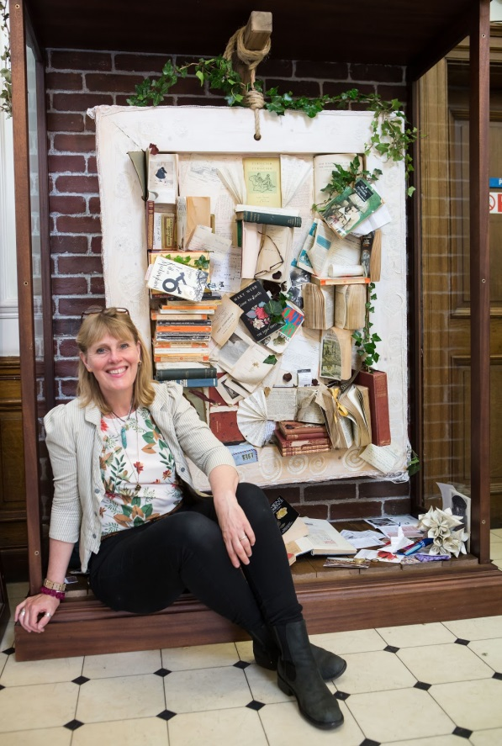
Elaine Robinson at Westminster Library pictured in front of Turning ‘ages Installation
(further images available on request)

Elaine works in a number of different formats and mediums, from watercolours to fibre glass, participatory events to installation, but her aim is always the same throughout;
She said: “I have always been an artist who tries to draw people into the work. It is important for me that people are encouraged to discuss the fast changing world and the way they interact with their environment."
“I feel that my responsibility as an Artist is to take an active role and the best way to do that is to get people in the community involved. A lot of what I do is about talking directly to people and encouraging them to be creative and add something to my work.”
Website: www.elainerobinson.co.uk
-Ends-

Notes for Editors:

About the Artist:
Elaine Robinson’s art explores connection, ancestry, nature, time and space.
Born in the north of England and gaining an art and music degree, Elaine worked in business and social work before becoming a professional artist. Elaine has developed an approach to art and expression by working instinctively in what she terms the ‘moving moment’.
Installation and sculpture is an area where she is able to explore more fully aspects of nature, evolution and our concepts of time. She is fascinated by how humans have become less trusting of these ancient and proven realities. Elaine documents these new social landscapes by challenging social barriers and encouraging public opinion, aspiring to create a document of previously unseen social comment. Elaine’s work asks us reflect and consider all of our sensory perceptions of ourselves and of each other.
Turning ‘ages is an installation which completed a two year city library exhibition around the UK. The work now permanently resides in the Westminster Reference Library in London’s West End. It is the first expression /installation in a series of seven artworks which are collectively known as ‘LIGAR’. The work has inspired writing groups across the country, and information regarding these interpretations and more general information about the tour can be seen by visiting the blog page of the website.
Elaine is now seeking permanent sponsors to further develop ‘LIGAR’
The 2nd expression of ‘LIGAR’ – ‘SPOTtimespotTIME’ will be touring from August 2016. Please view the tour page of the website. A further Press Release for this upcoming project will follow shortly.

Please contact Elaine regarding sponsorship approaches and also commission related work.
Exploring aspects of time in relation to the person, Elaine’s paintings have a personal message on the back which is written at the time of ownership. These are unique paintings, no prints are made.
Elaine is part of the ‘manifest artists’ group, which is based in Bristol UK.

Contact details for Elaine Robinson
info: www.elainerobinson.co.uk
tel: 07764894428
email: info@elainerobinson.co.uk

